**What is cloud migration?**

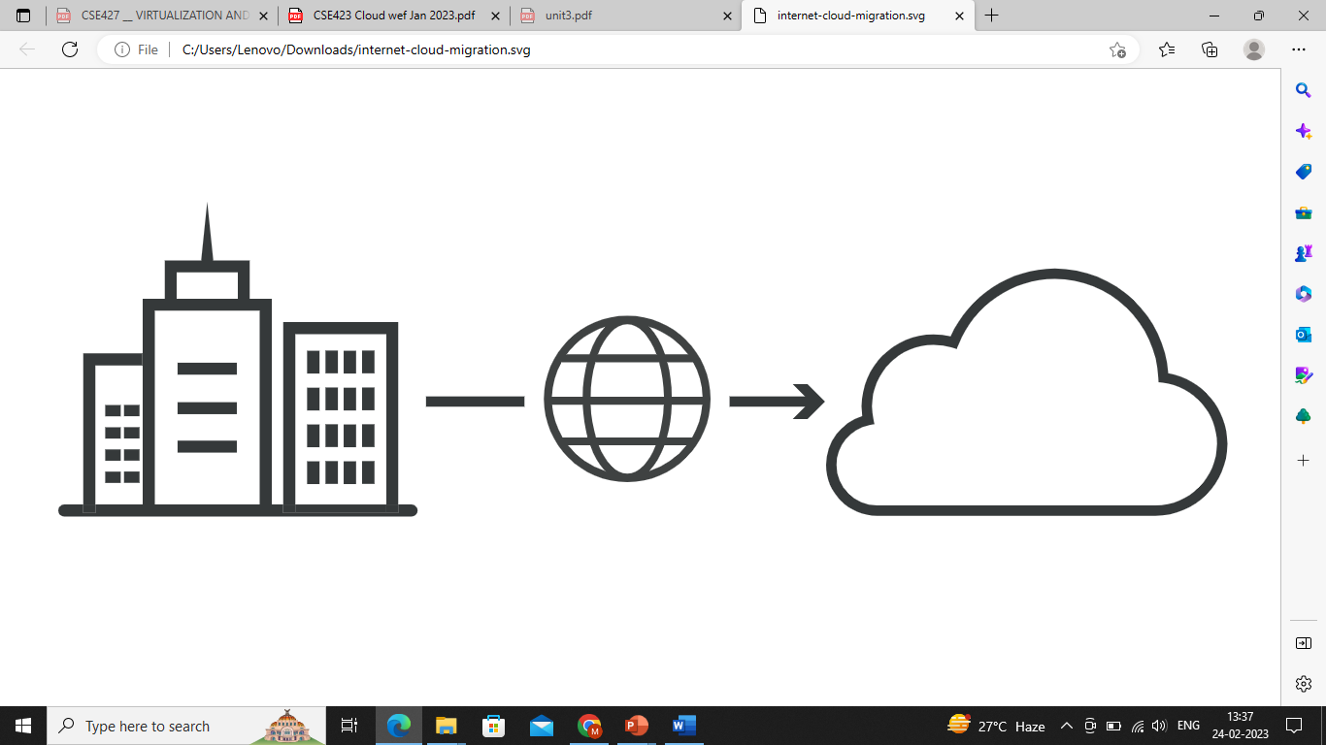

Cloud migration is the process of moving digital business operations into the [cloud](https://www.cloudflare.com/learning/cloud/what-is-the-cloud/). Cloud migration is sort of like a physical move, except it involves moving data, applications, and IT processes from some data centers to other data centers, instead of packing up and moving physical goods. Much like a move from a smaller office to a larger one, cloud migration requires quite a lot of preparation and advance work, but usually it ends up being worth the effort, resulting in cost savings and greater flexibility.

Most often, "cloud migration" describes the move from on-premises or legacy infrastructure to the cloud. However, the term can also apply to a migration from one cloud to another cloud.

**What is legacy infrastructure?**

In computing, hardware or software is considered "legacy" if it is outdated but still in use. Legacy products and processes are usually not as efficient or secure as more up-to-date solutions. Businesses stuck running legacy systems are in danger of falling behind their competitors; they also face an increased risk of [data breaches](https://www.cloudflare.com/learning/security/what-is-a-data-breach/).

Legacy software or hardware may become unreliable, may run slowly, or may no longer be supported by the original vendor. Windows XP, for instance, is a legacy operating system: released in 2001, its capabilities have been exceeded by later releases of Windows, and Microsoft no longer supports the operating system by releasing patches or updates for it.

Infrastructure includes servers, networking equipment, applications, databases, and any other business-critical software or hardware. Legacy infrastructure, such as aging servers or physical [firewall](https://www.cloudflare.com/learning/security/what-is-a-firewall/) appliances, may slow down a company's business processes. It may also add more security risks as original vendors drop support for their products and stop releasing security patches.

Legacy infrastructure is typically hosted on-premises, meaning it is physically located in buildings or on property where the organization operates. For instance, many businesses host an on-premises data center in the same building where their employees work.

Companies that rely on on-premises legacy infrastructure are unable to experience the benefits of cloud computing. Because of this, most enterprises today have made at least a partial migration to the cloud.

**What are the main benefits of migrating to the cloud?**

* **Scalability**: Cloud computing can scale up to support larger workloads and greater numbers of users far more easily than on-premises infrastructure, which requires companies to purchase and set up additional physical servers, networking equipment, or software licenses.
* **Cost**: Companies that move to the cloud often vastly reduce the amount they spend on IT operations, since the cloud providers handle maintenance and upgrades. Instead of keeping things up and running, companies can focus more resources on their biggest business needs – developing new products or improving existing ones.
* **Performance**: For some businesses, moving to the cloud can enable them to improve [performance](https://www.cloudflare.com/learning/performance/why-site-speed-matters/) and the overall user experience for their customers. If their application or website is hosted in cloud data centers instead of in various on-premises servers, then data will not have to travel as far to reach the users, reducing [latency](https://www.cloudflare.com/learning/performance/glossary/what-is-latency/).
* **Flexibility**: Users, whether they're employees or customers, can access the cloud services and data they need from anywhere. This makes it easier for a business to expand into new territories, offer their services to international audiences, and let their employees work flexibly.

**What are the main challenges of migrating to the cloud?**

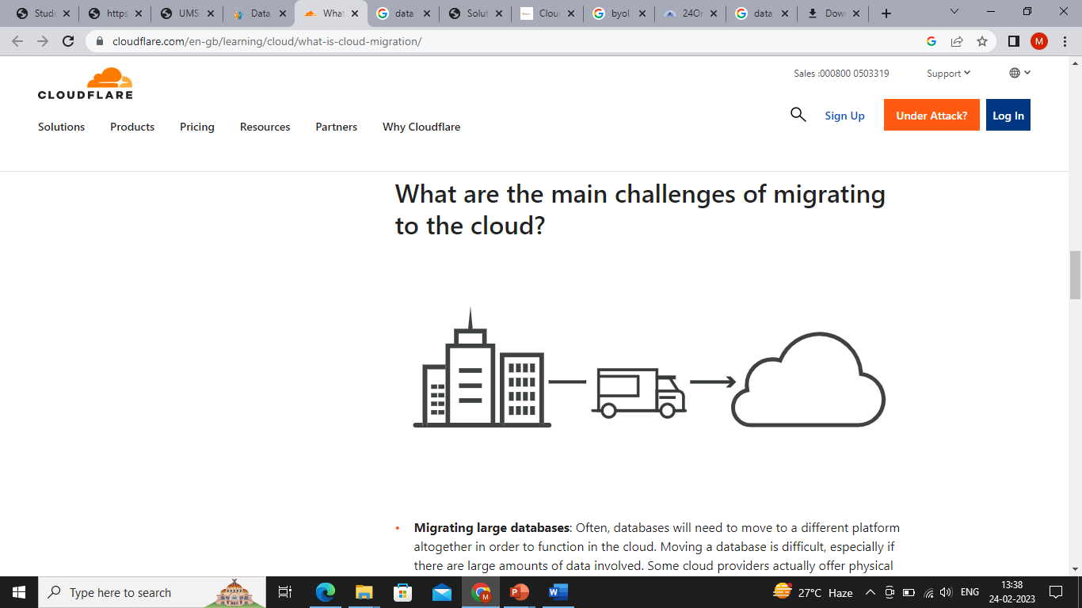

* **Migrating large databases**: Often, databases will need to move to a different platform altogether in order to function in the cloud. Moving a database is difficult, especially if there are large amounts of data involved. Some cloud providers actually offer physical data transfer methods, such as loading data onto a hardware appliance and then shipping the appliance to the cloud provider, for massive databases that would take too long to transfer via the Internet. Data can also be transferred over the Internet. Regardless of the method, data migration often takes significant time.
* **Data integrity**: After data is transferred, the next step is making sure data is intact and secure, and is not leaked during the process.
* **Continued operation**: A business needs to ensure that its current systems remain operational and available throughout the migration. They will need to have some overlap between on-premises and cloud to ensure continuous service; for instance, it's necessary to make a copy of all data in the cloud before shutting down an existing database. Businesses typically need to move a little bit at a time instead of all at once.

**How does an on-premises-to-cloud migration work?**

Every business has different needs and will therefore follow a slightly different process for cloud migrations. Cloud providers can help businesses set up their migration process. Most cloud migrations will include these basic steps:

1. **Establish goals**: What performance gains does a business hope to see? On what date will legacy infrastructure be deprecated? Establishing goals to measure against helps a business determine if the migration was successful or not.
2. **Create a security strategy**: [Cloud cybersecurity](https://www.cloudflare.com/learning/cloud/what-is-cloud-security/) requires a different approach compared to on-premises security. In the cloud, corporate assets are no longer behind a firewall, and the [network perimeter](https://www.cloudflare.com/learning/access-management/what-is-the-network-perimeter/) essentially does not exist. Deploying a [cloud firewall](https://www.cloudflare.com/learning/cloud/what-is-a-cloud-firewall/) or a [web application firewall](https://www.cloudflare.com/learning/ddos/glossary/web-application-firewall-waf/) may be necessary.
3. **Copy over data**: Select a cloud provider, and replicate existing databases. This should be done continually throughout the migration process so that the cloud database remains up-to-date.
4. **Move business intelligence**: This could involve refactoring or rewriting code (see below). It can be done piecemeal or all at once.
5. **Switch production from on-premises to cloud**: The cloud goes live. The migration is complete.

Some businesses turn off their on-premises infrastructure at the end of these steps, while others may keep legacy systems in place as backup or as part of a [hybrid cloud](https://www.cloudflare.com/learning/cloud/what-is-hybrid-cloud/) deployment.

**What cloud migration strategy should enterprises adopt?**

Gartner, a highly influential information technology research company, [describes](https://web.archive.org/web/20130123224850/http:/www.gartner.com/newsroom/id/1684114) 5 options for organizations migrating to the cloud. These cloud migration strategies are commonly known as the "5 R's":

* **Rehost** - Rehosting can be thought of as "the same thing, but on cloud servers". Companies that choose this strategy will select an [IaaS (Infrastructure-as-a-Service)](https://www.cloudflare.com/learning/cloud/what-is-iaas/) provider and recreate their application architecture on that infrastructure.
* **Refactor** - Companies that choose to refactor will reuse already existing code and frameworks, but run their applications on a [PaaS (Platform-as-a-Service)](https://www.cloudflare.com/learning/serverless/glossary/platform-as-a-service-paas/) provider's platform – instead of on IaaS, as in rehosting.
* **Revise** - This strategy involves partially rewriting or expanding the code base, then deploying it by either rehosting or refactoring.
* **Rebuild** - To "rebuild" means rewriting and re-architecting the application from the ground up on a PaaS provider's platform. This can be a labor intensive process, but it also enables developers to take advantage of modern features from PaaS vendors.
* **Replace** - Businesses can also opt to discard their old applications altogether and switch to already-built [SaaS (Software-as-a-Service)](https://www.cloudflare.com/learning/cloud/what-is-saas/) applications from third-party vendors.

**What cloud deployment style should companies choose?**

In addition to cloud migration strategy, businesses need to decide how their cloud deployment will look once the migration is complete.

A **hybrid cloud** mixes two or more types of environments, combining [public clouds](https://www.cloudflare.com/learning/cloud/what-is-a-public-cloud/), [private clouds](https://www.cloudflare.com/learning/cloud/what-is-a-private-cloud/), or on-premises legacy data centers. For a hybrid cloud deployment to work well, integration must be tight across all deployed clouds and data centers – just as team members need especially tight communication if they're spread out across different offices.

A **multicloud** deployment combines two or more public clouds. (Public clouds are shared by more than one customer.) [Multicloud](https://www.cloudflare.com/learning/cloud/what-is-multicloud/) can serve several purposes: redundancy/backup, cost savings, or leveraging features from different cloud providers, for instance.

Deploying a **single cloud** from just one cloud vendor is not always feasible for a business, but it is an option. Cloud providers offer both public clouds and private clouds – the difference being that private clouds are not shared with any other business.